For Sale
Alberg 30 Sailboat

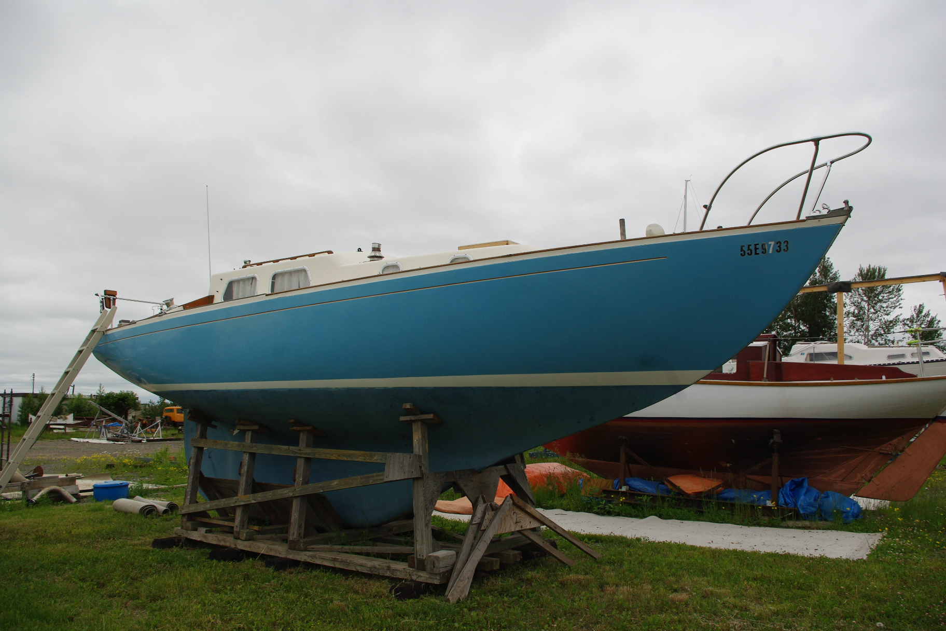

The Alberg 30 is a classic sloop rigged sailboat. She is a comfortable cruising yacht and a capable racing boat as well. Built to high standards, the Lady Sarah is simple to operate and well suited for cruising on Lake Superior. She is a one owner boat that has always been operated in fresh water. Located in Thunder Bay, Ontario.

Details

Built by Whitby Boat Works | Year 1969
Length | 30 feet
Beam | 8 feet 7 inches
Displacement | 9,000 lbs
Draft | 4 feet 3 inches
Engine | Atomic 4 30 HP (gasoline)
Fuel | 15 gallon gas tank
Sails | Main, 150% jib, 180% jib, spinnaker, storm jib
Steering | Wheel steering with emergency tiller
Electronics | VHF radio, stereo
Navigation | Danforth Constellation compass, knot meter
Interior layout | Main cabin saloon, forward vee birth
Galley | 2 burner propane stove, sink, fresh water hand pump
Head | Manual head, FRP holding tank, sink and hand pump
Anchor, mooring | 20 lb. Danforth, chain and rode

For more information contact Bud Saunders 807-623-0005

Asking price $7,500 or best offer
